



STEPS PODCAST
Creating A Website with docker
Progressive Pull Org ®

Contents
Installed Software 1
Introduction 1
Git 1
Source Tree 2
NodeJS and NPM 3
GitHub Desktop 4
Visual Studio Code 4
Docker Desktop 5

Installed Software

Introduction
I’m not going to walk you through the installation process for this software. You can find plenty of tutorials on YouTube. Instead, I’ll provide you with a list of the software you need for your machine.

Git
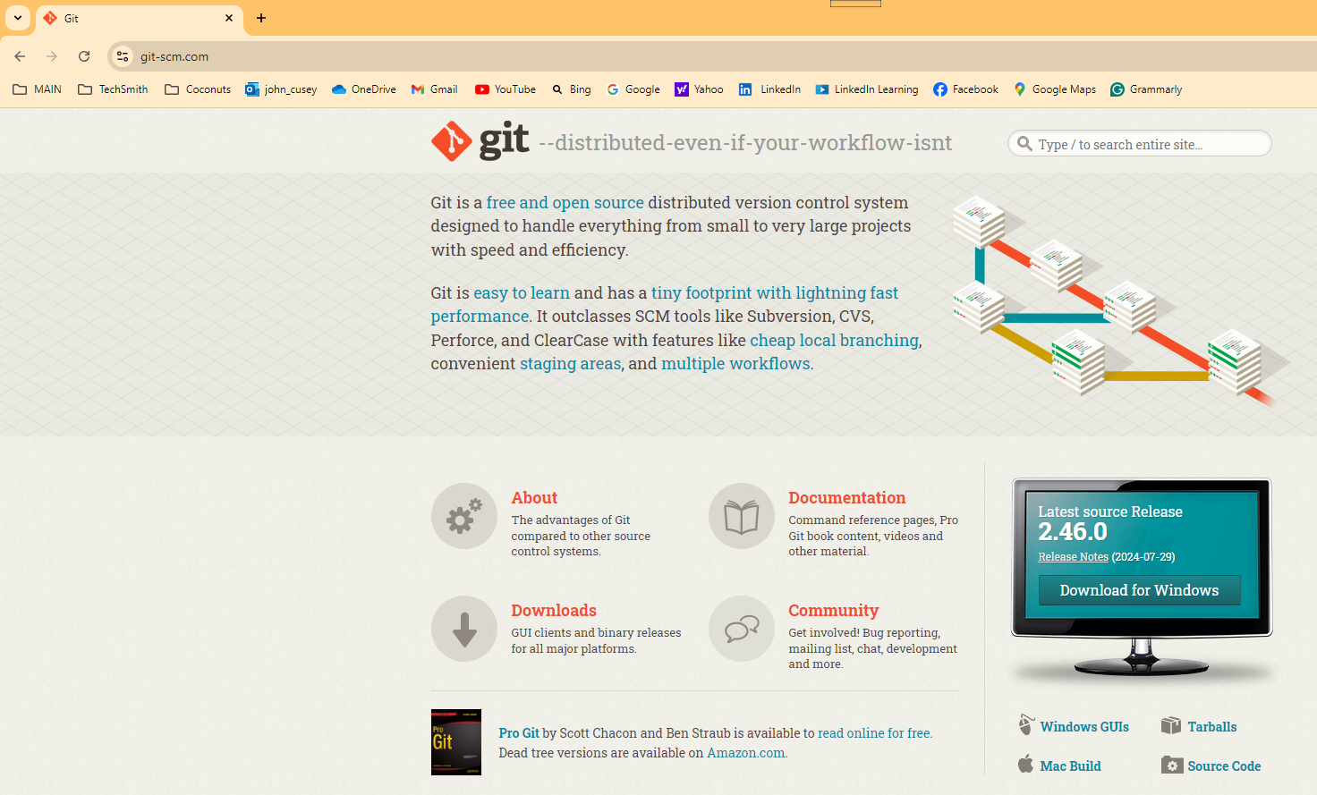
One essential software package to install on your computer is Git—not GitHub or GitLab. Git is a distributed version control system, extensively used in software development. Think of it as the backbone of collaborative coding. When you're working on a project with multiple people, Git tracks all the changes made to the code, who made them, and when. This allows multiple developers to work on the same project at the same time without interfering with each other's work.
While Git, GitHub, and GitLab are all related to version control and managing code, they serve different purposes. After installing Git on your computer, you can access it with command-line window. GitHub is a web-based platform that uses Git for version control. GitLab is a web-based DevOps lifecycle tool that provides a Git repository manager.
https://git-scm.com/

Source Tree
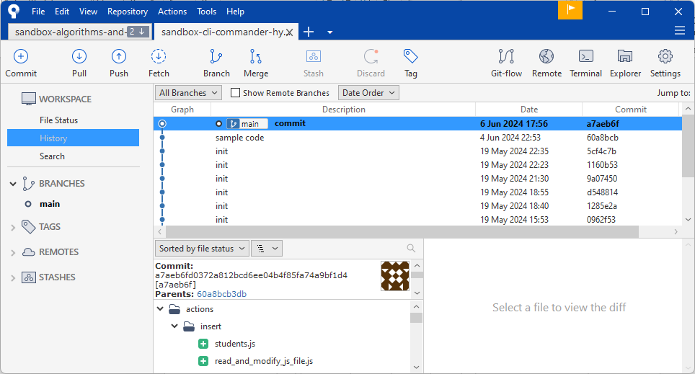
SourceTree is a free Git client developed by Atlassian. It provides a graphical user interface (GUI) for managing Git repositories, making it easier for both beginners and experienced developers to interact with Git without needing to use the command line
SourceTree simplifies how you interact with your Git repositories so you can focus on coding. Visualize and manage your repositories through SourceTree’s simple Git GUI.
https://www.sourcetreeapp.com/

NodeJS and NPM
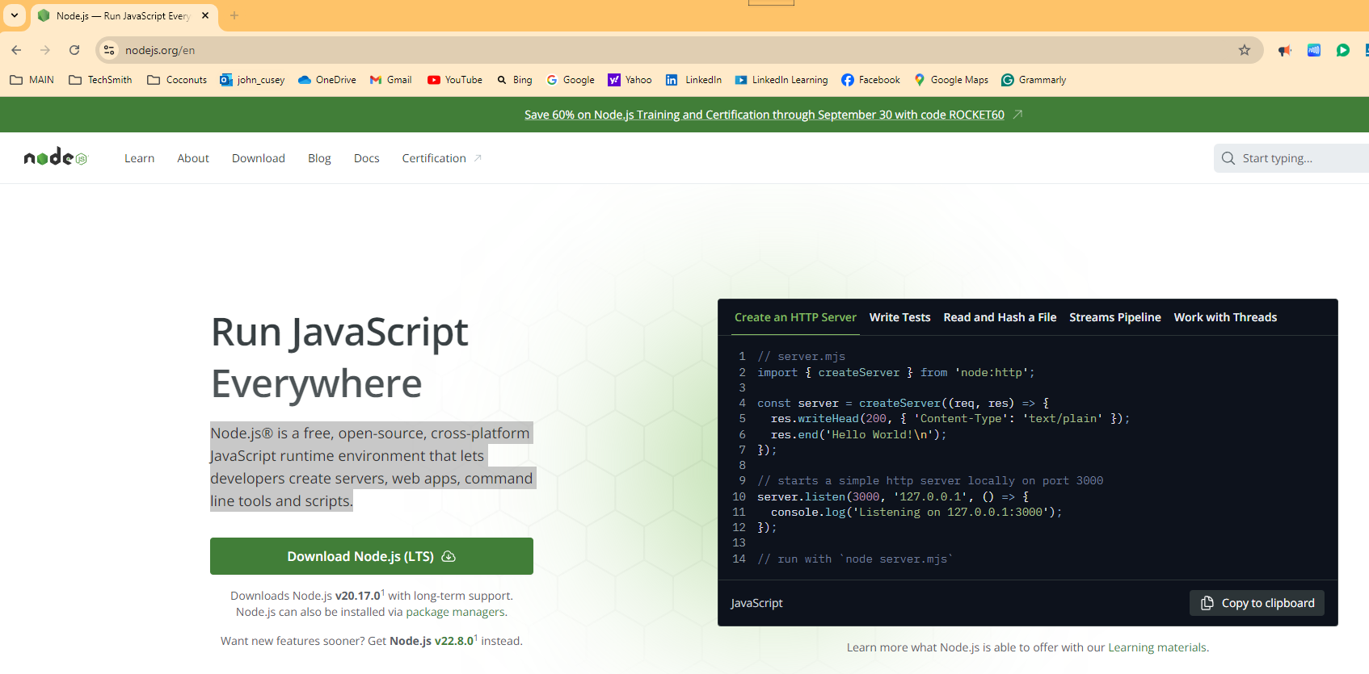
Another important software package to install is Node.js, an open-source, cross-platform runtime environment that allows you to execute JavaScript code outside of a web browser. It's built on Chrome's V8 JavaScript engine, which enables developers to use JavaScript for server-side scripting.
Node.js comes with NPM (Node Package Manager), the standard package manager for Node.js. The NPM webpage, npmjs.com, is the official site where you can browse packages, read documentation, and find general information about NPM. The site also offers resources for both free and Pro users, including various tools for JavaScript development.

https://nodejs.org/en

GitHub Desktop
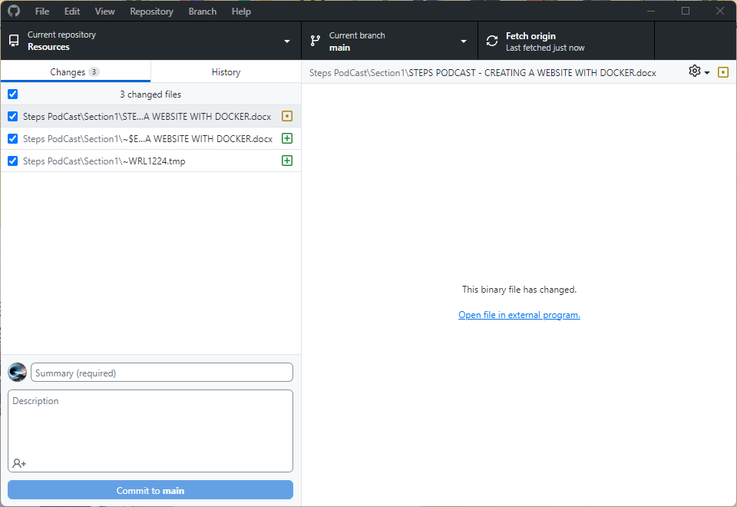

GitHub Desktop is a free, open-source application created to streamline your development workflow. It enables you to interact with GitHub repositories using a graphical user interface (GUI) rather than the command line or a web browser. You can decide which files to commit to your GitHub repository, and each commit will include the author's name and a commit message. If there are files you don't want to commit, you can add file path and file name to the .gitignore file.

https://github.com/apps/desktop

Visual Studio Code

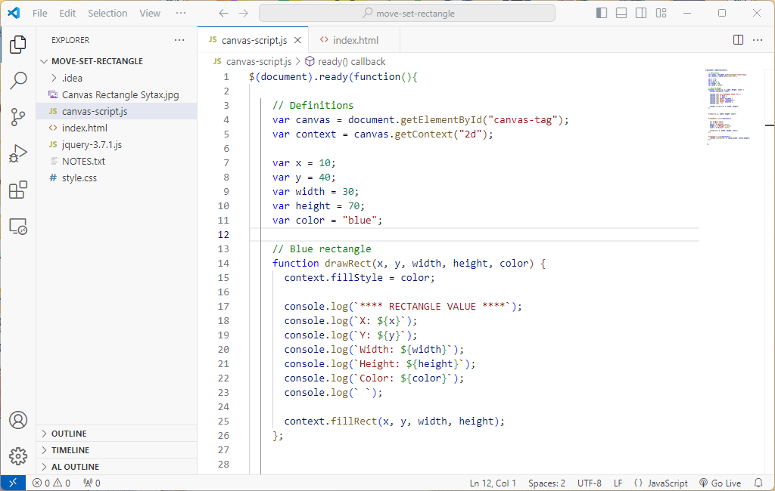
Visual Studio Code, commonly known as VS Code, is a free, lightweight, yet powerful source code editor developed by Microsoft. Its key features include integrated debugging tools, syntax highlighting to aid in reading and understanding code, intelligent code completion that suggests code based on context, reusable snippets of code, code refactoring tools to restructure code without changing its behavior, and built-in support for version control with Git.
https://code.visualstudio.com/

Docker Desktop

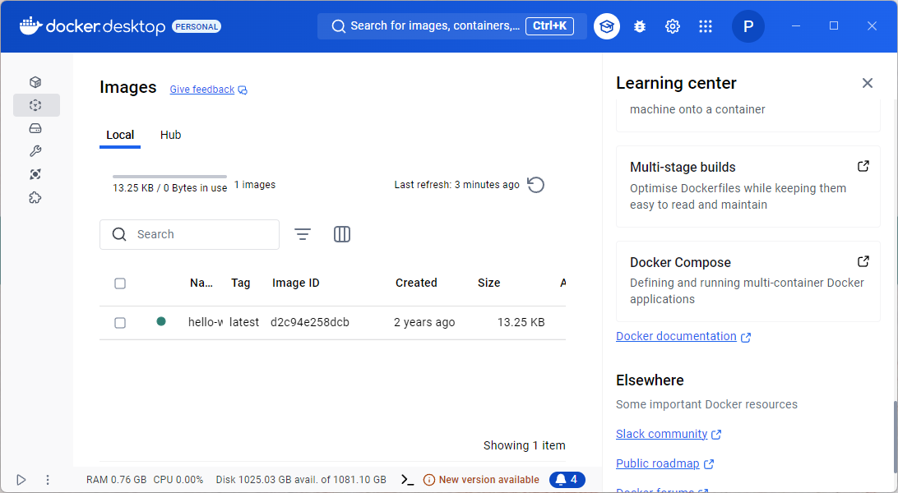
Docker Desktop is a widely used application that simplifies the process of building, sharing, and running containerized applications. It offers an intuitive user interface and comprehensive CLI tools to manage Docker containers and images seamlessly. With Docker Desktop, developers can create, test, and debug containers on their local machines before deploying them to production environments. It supports both Windows and macOS operating systems, making it a versatile tool for developers across different platforms.
Key features include Kubernetes integration, which allows developers to run Kubernetes clusters locally, and robust support for various programming languages and frameworks. Docker Desktop is essential for streamlining development workflows and ensuring consistency across different stages of application deployment.
https://www.docker.com/products/docker-desktop/

